# Lockleys Pilon Blue Mountains NSW Change Detection 2019-2023 Report

Prepared by [Michael Dear](https://mjdear68.github.io/portfolio/), April 2024

## Links

## Glossary

Mean: the average of a set of numbers.

Normalised Difference Vegetation Index (NDVI): The NDVI is a common remote sensing index used for the assessment of vegetation cover and vigour. The NDVI has values in the range of -1 to 1. Values below 0 are generally associated with deep water. Values above 0.8 are associated with dense forest.

Masked: Pixels that were excluded from the dataset due to a lack of data e.g. cloud cover

RGB: Red, green, and blue wavelength bands.

NIR: Near infrared wavelength band. The NIR and red bands are combined to create the NDVI.

## Key Points

## Method

Sentinel 2 satellite data was obtained from [Digital Earth Australia's](https://www.dea.ga.gov.au/) Open Data Cube for two dates in each of November 2019 and November 2024. Each plot in the study area was represented by one pixel in the dataset. The two dates for each year were averaged to form RGB, NIR and NDVI datasets. True-colour (RGB) and NDVI images of the study area and its surrounds were plotted and reviewed. A land cover classification was developed using NDVI thresholds, from which class change matrices and a class change map were produced. The NDVI thresholds and class descriptions are contained in Table 1.

Table 1   
NDVI thresholds and descriptions

|  |  |  |  |
| --- | --- | --- | --- |
| **Class Number** | **Class Name** | **Class Description** | **Threshold** |
| 1 | Water | Deep water bodies e.g. lakes, rivers |  |
| 2 | Bare | Bare ground |  |
| 3 | Sparse | Sparse vegetation e.g. scattered shrubs, patchy grass |  |
| 4 | Medium-density | Medium-density vegetation e.g. woodland; post-fire regrowth |  |
| 5 | High-density | Dense vegetation e.g. forest |  |
| 6 | Masked | No data | nan |

## Plots

### True-colour (RGB) Plots

Figure 1 contains a true-colour representation of the study area and its surrounds. The study area boundary is shown in blue. The 2023 image suggests an increase in bare ground when compared with the 2019 image. The Grose River in the top-left of the image also appears to be less vegetated in 2023, although the river was not included in the study area.

Figure 1   
True-colour (RGB) plots

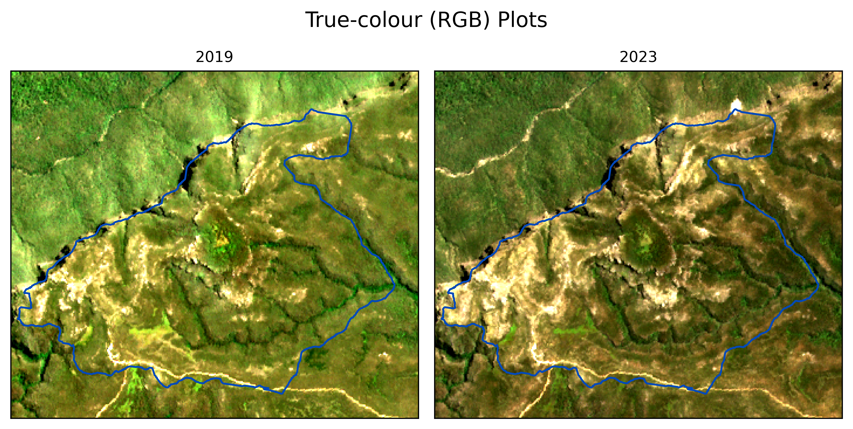

### Normalised Difference Vegetation Index (NDVI)

The NDVI plots indicate the regions of higher and lower 'greenness' for each period. The increase in orange-red areas in 2023 reflects lower vegetation cover. The red dot in the top-right of the image is due to a landslip that occurred after 2019.

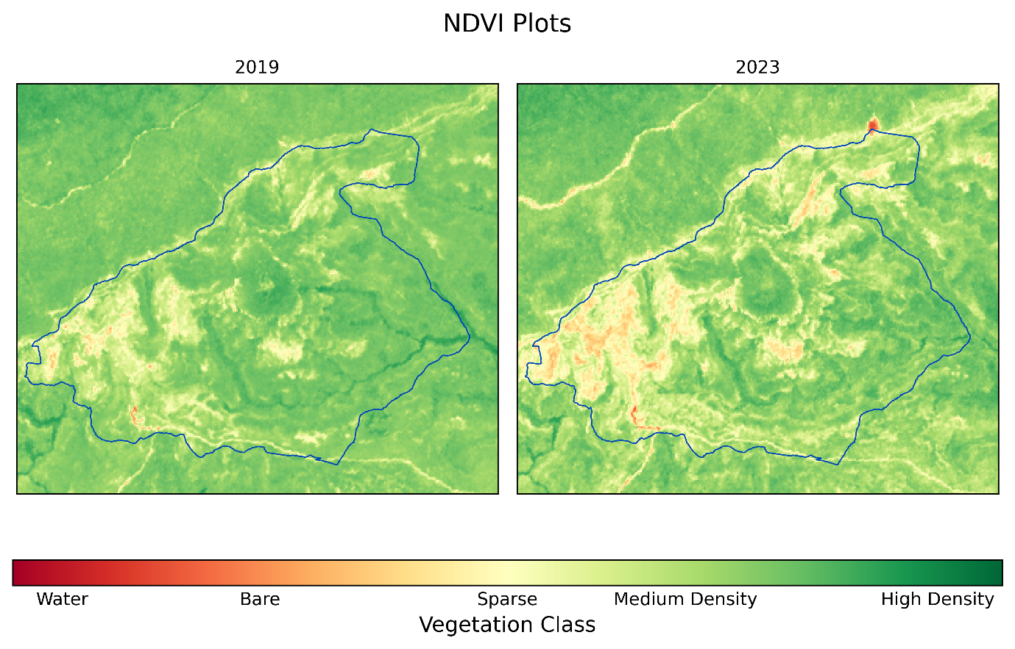

## Normalised Difference Vegetation Index (NDVI) Classification

Table 2 displays the percentage of each land cover class in the study area for the given years. Most of the vegetation belongs to the Medium Density class. The major changes occurred in the Sparse and Medium Density classes where the proportion of the Sparse class increased, and the Medium-density class decreased from 2019 to 2023. The High-density class also decreased during the study period.

Table 2   
Percentage of the study area in each class.

|  |  |  |  |  |  |  |  |
| --- | --- | --- | --- | --- | --- | --- | --- |
|  | **Water** | **Bare** | **Sparse** | **Medium Density** | **High Density** | **Masked** | **Total** |
| **2023** | 0.0 | 0.0 | 10.5 | 84.5 | 5.1 | 0.0 | 100.0 |
| **2019** | 0.0 | 0.0 | 2.1 | 91.2 | 6.7 | 0.0 | 100.0 |

Table 3   
Annual class differences (hectares, ha)

|  |  |  |  |  |
| --- | --- | --- | --- | --- |
|  | **2023** | **2019** | **2023-2019** | **Change_%** |
| **Water** | 0.00 | 0.00 | 0.00 | NaN |
| **Bare** | 0.01 | 0.00 | 0.01 | inf |
| **Sparse** | 45.97 | 9.23 | 36.74 | 398.0 |
| **Medium-density** | 371.29 | 400.88 | -29.59 | -7.4 |
| **High-density** | 22.36 | 29.52 | -7.16 | -24.3 |
| **Masked** | 0.00 | 0.00 | 0.00 | NaN |

### Class Change

The following table displays the area for each class in the current year as a percentage of the total area for each class from the previous year. The rows of the table represent 2023 and the columns represent 2024. A substantial proportion of the area classified as bare in 2023 was classified as sparse in 2024. Similarly, approximately one-third of the area classified as Sparse in 2023 was classified as Medium Density in 2024. In contrast to these upward classifications, more than half of the vegetation classified as High Density in 2023 was classified as Medium Density in 2024. These changes may be due in part to successional change following the 2019 fires, seasonal variation, and error in the classification mechanism.

|  |  |  |  |  |  |  |  |
| --- | --- | --- | --- | --- | --- | --- | --- |
|  | **2024** | | | | | | |
| **2023** |  | **Water** | **Bare** | **Sparse** | **Medium Density** | **High Density** | **Masked** |
| **Water** | 33.3 | 0.0 | 0.0 | 0.0 | 0.0 | 66.7 |
| **Bare** | 0.0 | 45.0 | 35.0 | 5.0 | 0.0 | 15.0 |
| **Sparse** | 0.0 | 0.1 | 63.0 | 33.2 | 0.4 | 3.4 |
| **Medium Density** | 0.0 | 0.0 | 1.3 | 90.0 | 1.7 | 7.0 |
| **High Density** | 0.0 | 0.0 | 0.3 | 56.2 | 38.7 | 4.8 |
| **Masked** | 0.0 | 0.0 | 1.8 | 78.6 | 6.9 | 12.8 |